SHL Assessment Recommendation System - Complete Implementation Guide

Overview
This guide provides step-by-step instructions to build, test, and deploy the SHL Assessment Recommendation System for your take-home assessment.
Project Goals
- Scrape 377+ Individual Test Solutions from SHL catalog
- Build AI-powered recommendation engine using LLM + Vector Search
- Create REST API with health and recommendation endpoints
- Develop web interface for testing
- Achieve Mean Recall@10 > 0.70
- Generate predictions on test set
- Deploy to cloud platform
Complete File Structure
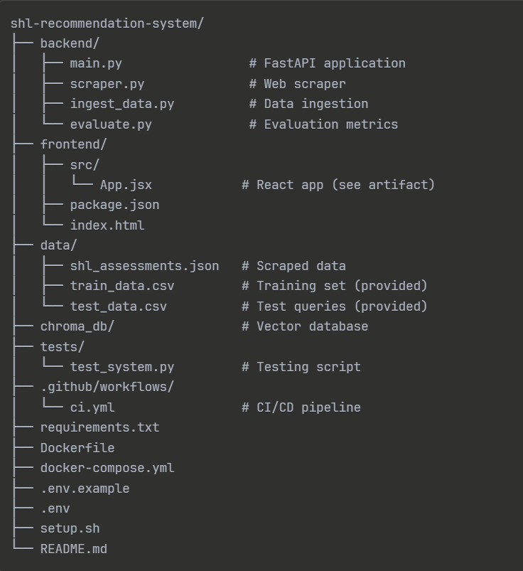
Phase 1: Initial Setup
1. Create Project Structure
# Create project directory
mkdir shl-recommendation-system
cd shl-recommendation-system

# Create subdirectories
mkdir -p backend frontend data tests .github/workflows

# Initialize git
git init
git remote add origin https://github.com/Manasvigiradkar
2. Set Up Python Environment
- D:\Resume and cover letter\SHL\shl-recommendation-system
- python -m venv venv
- venv\Scripts\activate
- (venv) D:\Resume and cover letter\SHL\shl-recommendation-system>

# Create requirements.txt (see artifact)
# Install dependencies
pip install -r requirements.txt
3. Get Gemini API Key
- Visit https://ai.google.dev/
- Click "Get API Key"
- Create a new API key (free tier)
- Copy the key
4. Configure Environment
# Create .env file
copy .env.example .env

# Edit .env and add your key
GEMINI_API_KEY=your_actual_api_key_here

Phase 2: Data Collection
To automatically collect SHL Individual Test Solutions data from the SHL catalog website, which is dynamically loaded and cannot be scraped reliably using only requests or BeautifulSoup.
Step 1: Go to Project Root Directory
cd "D:\Resume and cover letter\SHL\shl-recommendation-system"
Moves you into the SHL project folder.
Step 2: Activate Virtual Environment
venv\Scripts\activate
👉 Ensures:
- Selenium
- ChromeDriver
- All project dependencies
are available.
You’ll see:
(venv)
Step 3: Move to Backend Folder (if required)
cd backend
👉 Required if selenium_scraper.py is inside backend/.
Step 4: Execute Selenium Scraper
python selenium_scraper.py

Install Selenium
Step 1: Go to Your Project Folder
cd "D:\Resume and cover letter\SHL\shl-recommendation-system"
Step 2: Activate Virtual Environment
venv\Scripts\activate
You should see:
(venv)
Step 3: Install Selenium
pip install selenium
Step 4: Verify Installation (Optional but Recommended)
python -c "import selenium; print(selenium.__version__)"

Phase 3: Build Recommendation Engine
Step 1: Ingest Data into ChromaDB
- Go to directory: D:\Resume and cover letter\SHL\shl-recommendation-system
- Then activate environment
- Then cd backend
- Then run this python ingest_data.py or python backend/ingest_data.py --json-file data/shl_assessments.json
Output:
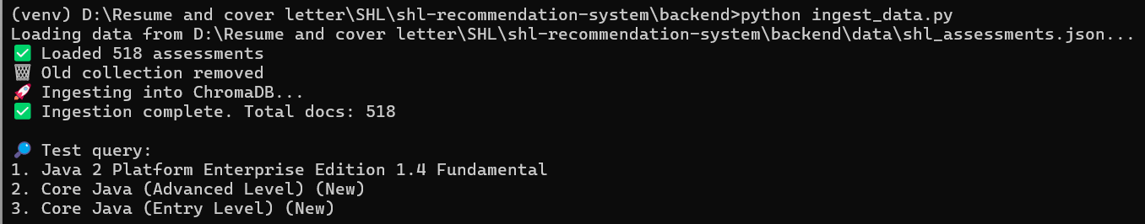
Step 2: Implement API
Use the main.py artifact. Key features:
- Query Enhancement: Expands queries using LLM
- Vector Search: Retrieves top 30 candidates
- LLM Reranking: Selects best 5-10 with balance
Step 3: Start API Server
- Go to directory: D:\Resume and cover letter\SHL\shl-recommendation-system
- Then activate environment
- Then cd backend
- Then run this :uvicorn main:app --reload --host 0.0.0.0 --port 8000
Output:
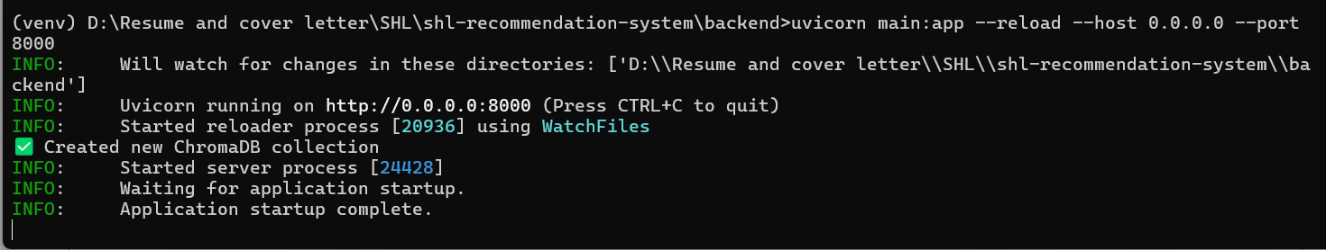
Test endpoints:
- http://localhost:8000/
output:
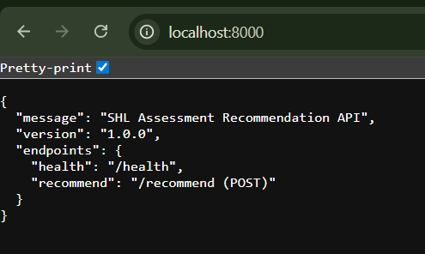
- http://localhost:8000/docs
- http://localhost:8000/health

Phase 4: Build Frontend
Step 1: Create React App
cd frontend
npm create vite@latest . -- --template react
npm install lucide-react
Step 2: Implement UI
Use the React artifact provided. Features:
- Query input textarea
- Sample query buttons
- Results table with rankings
- API endpoint configuration
- Error handling
Step 3: Start Frontend
npm run dev
Visit http://localhost:3000 and test the interface.

Frontend Deployment on Vercel
1. Install Vercel CLI
npm install -g vercel
2. Login to Vercel
vercel login
3. Deploy Frontend (Initial)
vercel
4. Add Backend API Environment Variable
vercel env add VITE_API_URL
5. Redeploy to Production
vercel –prod

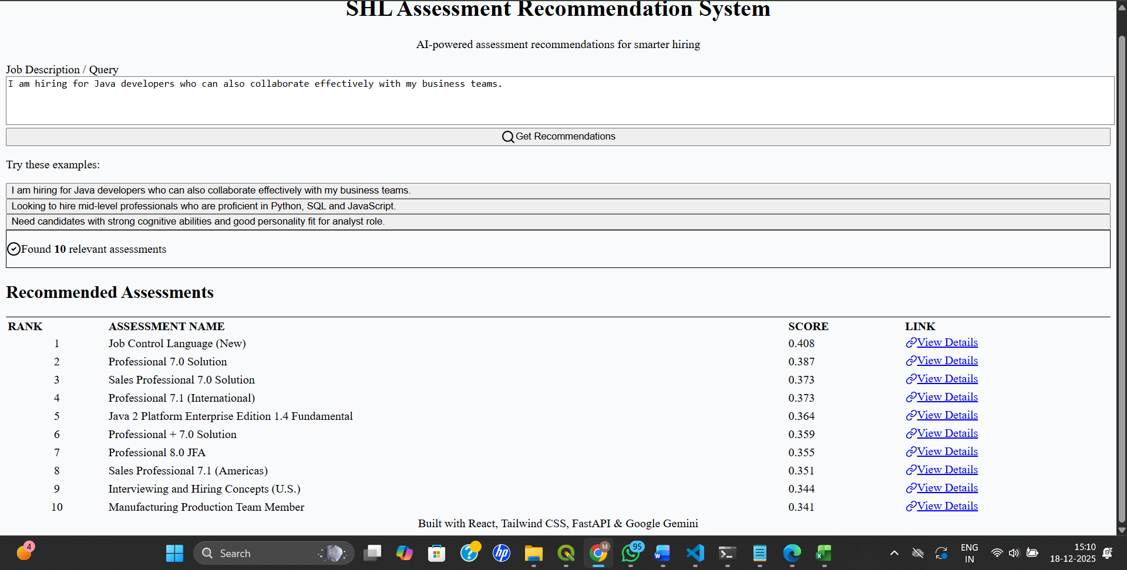

Phase 5: Evaluation & Optimization
Step 1: Download Training Data
Get the labeled training data from the provided link.
Format:
query,Assessment_url
"Java developer",https://www.shl.com/...
"Java developer",https://www.shl.com/...
Step 2: Run Initial Evaluation
python backend/evaluate.py --mode evaluate --train-csv data/train_data.csv
Expected output:
Mean Recall@10: 0.65
Mean Precision@10: 0.72
...
Step 4: Track Improvements
Create a log of iterations:
Iteration | Change | Mean Recall@10 | Notes
Baseline | Simple vector search | 0.58 | No balancing
v1 | Added query enhancement | 0.65 | +7% improvement
v2 | LLM reranking | 0.72 | +7% improvement
v3 | Balanced test types | 0.76 | +4% improvement

Phase 6: Testing
  - Start the backend first and that port by using above steps.
  - Run Comprehensive Tests
python tests/test_system.py --api-url http://localhost:8000
Tests include:
- Health check
- Recommendation quality
- Test type balancing
- Edge cases
- Performance benchmarks
Fix any failing tests before proceeding.

Phase 7: Generate Submissions
Step 1: Create Predictions CSV
python backend/evaluate.py --mode predict --test-csv data/test_data.csv --output-csv predictions.csv
Step 2: Validate CSV Format
import pandas as pd

df = pd.read_csv('predictions.csv')
print(df.head())

# Should have columns: query, Assessment_url
assert 'query' in df.columns
assert 'Assessment_url' in df.columns

# Each query should have 5-10 recommendations
print(df.groupby('query').size())

Phase 8: Deployment
STEP 1: Prepare Backend for Render
Confirm requirements.txt exists
Inside project root (or backend folder), must contain:
fastapi
uvicorn
chromadb
google-generativeai
sentence-transformers
python-dotenv
pydantic
STEP 2: Push Final Code to GitHub
From project root:
git add backend/main.py backend/ingest_data.py requirements.txt
git commit -m "Prepare backend for Render deployment"
git push origin main
STEP 3: Create Web Service on Render
- Go to 👉 https://render.com
- Login with GitHub
- Click New → Web Service
- Select your SHL GitHub repository
STEP 4: Configure Render Service
Fill details exactly like this
Field | Value
Name | shl-recommendation-api
Runtime | Python 3
Region | Singapore (or closest)
Branch | main
Root Directory | backend

STEP 5: Add Environment Variables (VERY IMPORTANT)
In Render → Environment → Add Environment Variable
Key | Value
GEMINI_API_KEY | your_actual_api_key

Submission :
API Endpoint URL: Render - Application loading
- GitHub URL: https://github.com/Manasvigiradkar/shl-recommendation-system
- Frontend URL: https://shl-recommendation-frontend.vercel.app/
- Approach Document: Upload PDF
- Predictions CSV: Upload predictions.csv

Common Issues & Solutions
Issue: Low Recall Score
Solutions:
- Increase top-k in vector search (try 50)
- Improve query enhancement prompts
- Check if all relevant assessments are in database
- Verify embeddings are created correctly
Issue: Slow API Responses
Solutions:
- Reduce LLM reranking candidates (top 20 instead of 30)
- Use Gemini Flash instead of Pro
- Implement caching for common queries
- Optimize ChromaDB queries
Issue: Imbalanced Recommendations
Solutions:
- Add explicit test type balancing in LLM prompt
- Implement post-processing to ensure diversity
- Use metadata filtering in vector search
- Create test type scoring function
Issue: Scraping Fails
Solutions:
- Use Selenium for JavaScript-rendered pages
- Add User-Agent headers
- Implement retry logic with exponential backoff
- Consider manual data collection as fallback
Additional Resources
- Gemini API: https://ai.google.dev/docs
- ChromaDB: https://docs.trychroma.com/
- FastAPI: https://fastapi.tiangolo.com/
- React: https://react.dev/
- Deployment: See README for platform-specific guides

